**How would you improve your community?**

**In partnership with Cities of Service, Find It, Fix Community Walks Program is offering**

**mini-grants to past Community Walk neighborhoods to support community-led**

**revitalization and beautification projects.**

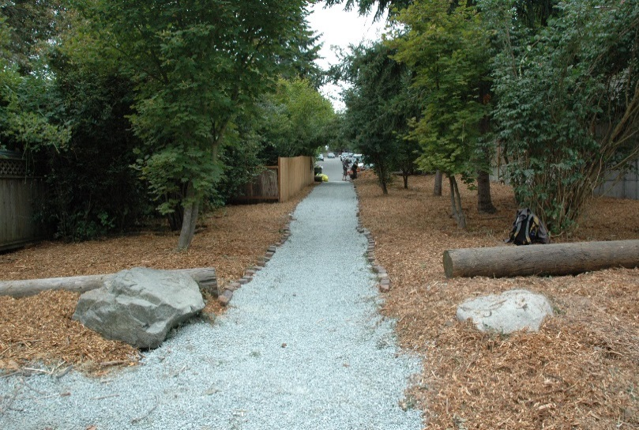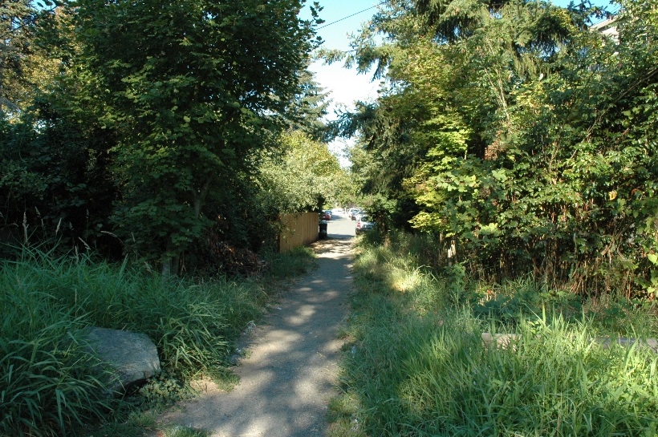

**BEFORE**

**AFTER**

**What can you do with a Community Project Grant?**

* Host litter pick-up or graffiti clean-up events
* Plant trees or flowers along a sidewalk or street median
* And more!
* Learn more about past Community Project Grants by visiting [www.seattle.gov/finditfixit](http://www.seattle.gov/finditfixit)

**Project Requirements**

*Proposed projects must be:*

* Funded independently or through a fiscal sponsor prior to being reimbursed
* Visible from the street or another public place
* Completed (all grant funds used) by December 1, 2017

**Preference**

*Preference will be given to projects that:*

* Recruit neighbors and community members as volunteers
* Partner with neighborhood organizations, nonprofit organizations, and/or businesses
* Take advantage of City programs (e.g., [Adopt-a-Street](http://www.seattle.gov/util/EnvironmentConservation/OurCity/AdoptaStreet/index.htm), [Trees for Seattle](http://www.seattle.gov/trees/treeambassador.htm))
* Improve the safety and/or appearance of a public space or structure

**Frequently Asked Questions**

*Contact Paige Madden at* [*paige.madden@seattle.gov*](mailto:paige.madden@seattle.gov)*, (206) 233-5166 or Laura Jenkins at* [*laura.jenkins@seattle.gov*](mailto:laura.jenkins@seattle.gov)*, (206) 684-0320 with additional questions*

**Can I apply for a Community Project Grant if I didn’t attend the walk?**

Yes! All community members within the walk neighborhood are eligible to apply.

**How will I pay for the Find It, Fix It Community Project?**

The Find It, Fix It program cannot grant money in advance for projects. This means that the project must be

funded independently or in partnership with an organization that can help pay for the initial expenses. After

all materials are purchased for the project and original receipts are turned in, the City of Seattle will send reimbursement within 2 weeks. If you cannot pay for the project up front, please contact Paige Madden at [paige.madden@seattle.gov](mailto:paige.madden@seattle.gov), (206) 233-5166 or Laura Jenkins at [laura.jenkins@seattle.gov](mailto:laura.jenkins@seattle.gov), (206) 684-0320 to discuss other options.

**How do I know if I need permits for my project?**

You can find more information about permits, when they are required, and how to obtain

them at [http://www.seattle.gov/dpd/permits/](http://www.seattle.gov/dpd/permits/%20) or call (206) 684-8850. It is good to budget for contingency

in case there are additional permits required.

**Can I use the money to help fund a preexisting project?**

Yes! The Find It, Fix It project money can be used top help fund existing projects if the grant money

is spent by December 1, 2017. However, grant funds can only be used to reimburse project materials

purchased after notification of award.

**Instructions**

Please type or print your answers to **all** sections (1 through 5) in the spaces provided. **Incomplete applications will delay grant awards**.

**Note**: Please attach additional pages if necessary. Paper applications available on request.

Please submit applications by **October 10 at 5pm** to:

Seattle Department of Neighborhoods

Attn: Find It, Fix It Community Walks

PO Box 94649

Seattle, WA 98124-4649

Or submit via email to [paige.madden@seattle.gov](mailto:paige.madden@seattle.gov) or laura.jenkins@seattle.gov

**If you missed the application deadline or you have questions:**

Please contact Paige Madden or Laura Jenkins at the above emails.

**Section 1:** *Applicant Information*

|  |  |
| --- | --- |
| 1. **Organization Name:** 2. **(if applicable)** | Click or tap here to enter text. |
| 1. **Project Contact Person:** | Click or tap here to enter text. |
| 1. **Phone Number:** | Click or tap here to enter text. |
| 1. **Email Address:** | Click or tap here to enter text. |
| **Project Address:** | Click or tap here to enter text. |
| **Neighborhood:** | Capitol Hill  Rainier Valley  Click or tap here to enter text. |

**Section 2:** *Project Information*

|  |
| --- |
| **Please provide a general overview of your proposed project and the community problem you are addressing (include photos if applicable):** |
| Click or tap here to enter text. |
| **Describe the outcomes/impacts that you hope to achieve:** |
| Click or tap here to enter text. |
| **Describe where the project is located. Please include intersections and landmarks if possible:** |
| Click or tap here to enter text. |
| **Name the organization(s) you will partner with on the project, if any, and provide its mission(s):** |
| Click or tap here to enter text. |

**Section 3:** *Volunteer Information*

|  |
| --- |
| **Please check the box with the number of volunteers you expect to be involved:** |
| 5  10  20  30  50+  Other: Click or tap here to enter text. |
| **Describe the specific ways you will recruit and engage community members. Describe who you will reach (e.g. merchants association, church youth group members) and how you will contact them:** |
| Click or tap here to enter text. |

**Section 4:** *Sustainability*

|  |
| --- |
| **How do you hope to maintain the project beyond the grant period? Please check all that apply:** |
| I plan to:  Create an ongoing group to maintain the project area twice a year  Ask an existing community group to perform ongoing maintenance  Work with Find It, Fix It Coordinators to create a plan for ongoing maintenance  Organize this as a one-time volunteer effort, but I recognize the need for ongoing community support  Other: Click or tap here to enter text. |

**Section 5:** *Budget (up to $1,500 or as funds allow)*

Complete a budget by listing each item you intend to purchase, how it will be used, and the cost of each item

including taxes. Costs should consist of one-time expenses such as supplies and/or services including tool rental.

The grant cannot compensate individuals for labor (that is where community volunteers come in).

**Grant recipients will be reimbursed for expenses upon submission of receipts and completion of the project**

**Example:**

|  |  |  |
| --- | --- | --- |
| **Item** | **Description of Use** | **Cost** |
| 3 gallons of paint | To paint the walls surrounding the community garden | $50.00 |
| 6 paint brushes | Needed to paint the walls of the community garden | $18.00 |
| **Total** |  | **$68.00** |

**Proposed Budget:**

|  |  |  |
| --- | --- | --- |
| **Item** | **Description of Use** | **Cost** |
| Click or tap here to enter text. | Click or tap here to enter text. | Click or tap here to enter text. |
| Click or tap here to enter text. | Click or tap here to enter text. | Click or tap here to enter text. |
| Click or tap here to enter text. | Click or tap here to enter text. | Click or tap here to enter text. |
| Click or tap here to enter text. | Click or tap here to enter text. | Click or tap here to enter text. |
| Click or tap here to enter text. | Click or tap here to enter text. | Click or tap here to enter text. |
| Click or tap here to enter text. | Click or tap here to enter text. | Click or tap here to enter text. |
| Click or tap here to enter text. | Click or tap here to enter text. | Click or tap here to enter text. |
| Click or tap here to enter text. | Click or tap here to enter text. | Click or tap here to enter text. |
| Click or tap here to enter text. | Click or tap here to enter text. | Click or tap here to enter text. |
| Click or tap here to enter text. | Click or tap here to enter text. | Click or tap here to enter text. |
| **Total** |  | Click or tap here to enter text. |